Project Design Phase
Solution Architecture

Date | 12 July 2026
Project Name | Customer Registry – MERN Stack Complaint & Customer Management System
Maximum Marks | 4 Marks

Solution Architecture:
Customer Registry follows a classic 3-tier architecture. A React single-page app serves three role-based UIs (Customer, Agent, Admin); every request passes through a stateless Express/Node.js REST API secured by JWT middleware; and all data is persisted in MongoDB Atlas across six Mongoose collections (Customer, Complaint, Agent, Category, Communication, Notification).

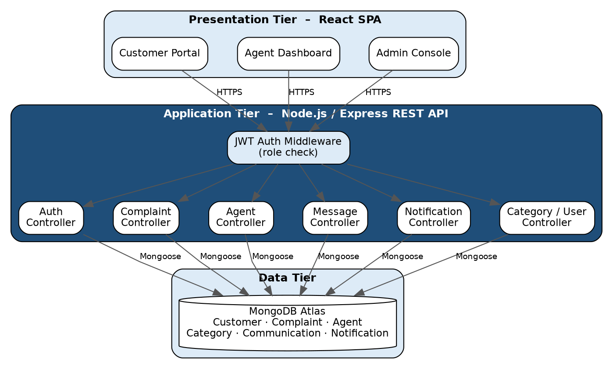
Figure 1: Solution architecture of Customer Registry – presentation, application and data tiers.

Layer | Responsibility
Presentation Tier | React SPA with role-scoped views: complaint form and status tracker for customers, assigned-complaint queue for agents, and full oversight console for admins. Communicates with the API over HTTPS using a JWT stored client-side.
Application Tier | Node.js/Express REST API. JWT auth middleware validates the token and role on every protected route before handing off to the relevant controller (Auth, Complaint, Agent, Message, Notification, Category/User).
Data Tier | MongoDB Atlas accessed through Mongoose schemas. Each domain concept – customers, complaints, agent assignments, categories, chat messages and notifications – is its own collection, related by ObjectId references.

